Project Report Format

INTRODUCTION
  - Project Overview
- Calculating Family Expenses using ServiceNow is a cloud-based system designed to record, manage, and analyze family expenses in a structured manner. Managing expenses manually using notebooks or spreadsheets is time-consuming and prone to errors. This project provides a centralized platform where users can enter expenses, categorize them, and generate monthly reports.
- The system is developed using the ServiceNow platform, focusing on administrator-level configuration such as user management, table creation, workflows, and reporting without complex coding.
Purpose
The purpose of this project is to:
- Track daily and monthly family expenses
- Reduce errors caused by manual calculations
- Provide clear expense visibility through reports
- Improve financial planning and budgeting
- Use a centralized and secure platform

IDEATION PHASE
  - Problem Statement
Families face difficulties in tracking and calculating expenses manually. The lack of a centralized system leads to confusion, inaccurate calculations, and poor budgeting. There is a need for a simple and reliable system to manage family expenses effectively.

  - Empathy Map Canvas
User Thinks:
- Where is my money being spent?
- How can I reduce unnecessary expenses?
User Feels:
- Confused during budgeting
- Worried about increasing expenses
User Says:
- I need a simple way to track expenses
- Monthly reports would help

User Does:
- Records expenses manually
- Calculates totals at month-end

  - Brainstorming
- Manual notebook-based tracking
- Excel-based expense management
- Mobile expense tracking apps
- Web-based expense system
- ServiceNow-based expense management system

REQUIREMENT ANALYSIS
  - Customer Journey map
- User logs into ServiceNow
- User enters expense details
- Expense is categorized
- Expense stored in ServiceNow table
- Monthly report generated
  - Solution Requirement

Functional Requirements
- User creation and role assignment
- Secure login using ServiceNow credentials
- Add daily family expenses
- Categorize expenses (food, rent, bills, etc.)
- Calculate daily and monthly expenses
- Generate expense reports and dashboards

Non-Functional Requirements
- User-friendly interface
- Accurate calculations
- Good system performance
- High availability
- Easy maintenance

  - Data Flow Diagram

Level 0 DFD

User → ServiceNow Expense System → Database → Reports

Level 1 DFD
- User enters expense
- Expense validation
- Data stored in table
- Calculation of totals
- Report generation

  - Technology Stack
- Platform: ServiceNow
- Modules: ITSM
- Database: ServiceNow Tables
- Tools: ServiceNow Studio, UI Forms, Reports
- Security: Role-based access control

PROJECT DESIGN
  - Problem Solution Fit
The proposed ServiceNow-based system effectively solves the problem of manual expense tracking by providing centralized data storage, accurate calculations, and automated reporting.
Proposed Solution
The system allows users to enter daily expenses through ServiceNow forms. Expenses are categorized and stored in tables. Reports and dashboards provide monthly and category-wise expense analysis..

Solution Architecture
User → ServiceNow UI → Expense Table → Workflow → Reports & Dashboards

PROJECT PLANNING & SCHEDULING
Project Planning
Phase 1 – Problem Analysis
Phase 2 – Requirement Analysis
Phase 3 – Table & Form Design
Phase 4 – Workflow Configuration
Phase 5 – Report Generation
Phase 6 – Testing & Demonstration

FUNCTIONAL AND PERFORMANCE TESTING
Performance Testing
- Expense entry processed correctly
- Reports generated accurately
- System response is satisfactory

RESULTS
  - ServiceNow Developer Instance Dashboard
  - ServiceNow Studio Environment
  - Family Expenses Form Design
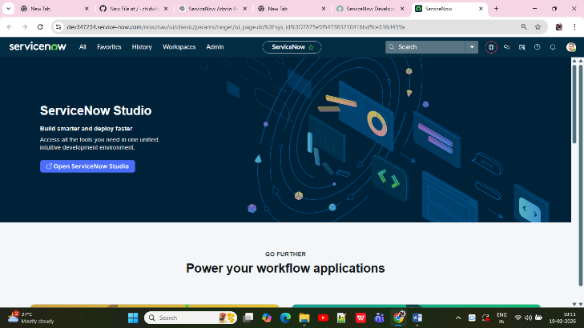
  - Daily Expenses Form Design
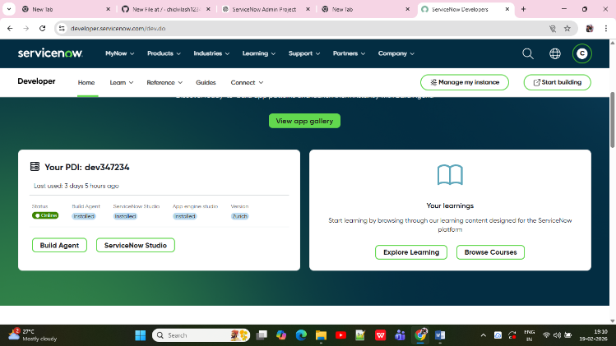
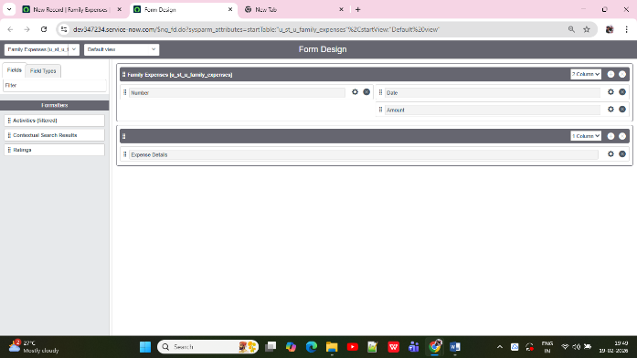
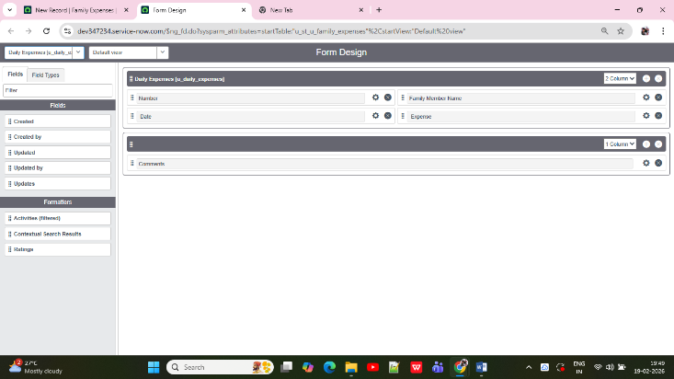

- ADVANTAGES & DISADVANTAGES

Advantages
- Centralized expense management
- Accurate calculations
- Easy reporting
- No complex coding
- Secure and reliable

Disadvantages
- Requires internet access
- Depends on ServiceNow availability

- CONCLUSION
The Calculating Family Expenses using ServiceNow project provides an efficient and reliable solution for managing household expenses. By leveraging ServiceNow administrator capabilities, the system eliminates manual errors and improves financial planning.
- FUTURE SCOPE
- Mobile access enhancement
- Automated budget alerts
- Advanced dashboards
- Integration with banking systems
- APPENDIX
- Custom Family Expenses Table Configuration
- Update Set for Family Expenses Project
- Relationship Configuration for Daily Expenses
- Business Rule Configuration for Family Expenses
- Appendix Summary:
The appendix provides configuration-level details including table design, update sets, relationships, and business rules implemented in ServiceNow.
- 
 